**Gemotric Intution:**

Let’s say we have points belonging to two classes, now there can be many planes that can separate them.

But which plane is the best for them?

In SVM we pick a plane that seperates +Ve and –ve pts as widely as possible.

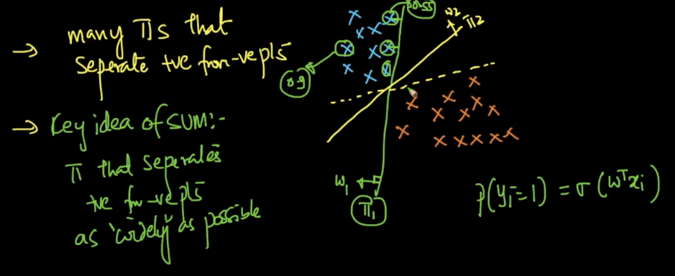

**How we find a plane that seperates +Ve and –ve pts as widely as possible ?**

Pick any random plane lets say pie. Now draw planes parallel to pie towards +ve points, by doing this the plane which intersect any of the +Ve point is called pie+.

Similarly draw planes parallel to pie towards –ve points, by doing this the plane which intersect any of the –Ve point is called pie-.

Now we’ll find distance between pie+ and pie-, let’s say it ‘d’ it’s called **margin distance**.

So what SVM says is that pick that plane as best plane whose distance between +ve plane and –ve plane is maximum.

Here pie is called separating plane, pie+ is +ve plane and pie- is –ve plane.

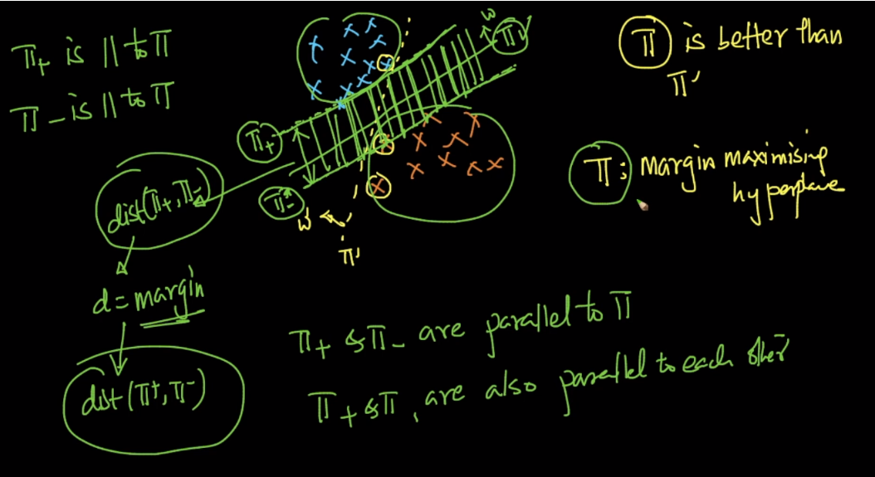

Why we are seeking for maximum margin distance, because as margin increases, genearalization accuracy also increases

Genearalization accu: accuracy of finding the class of unseen datapoints.

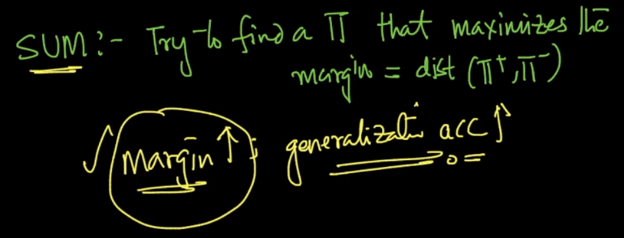

**Support Vectors:**

All the points through which pie+ or pie- pass through are called support vectors.

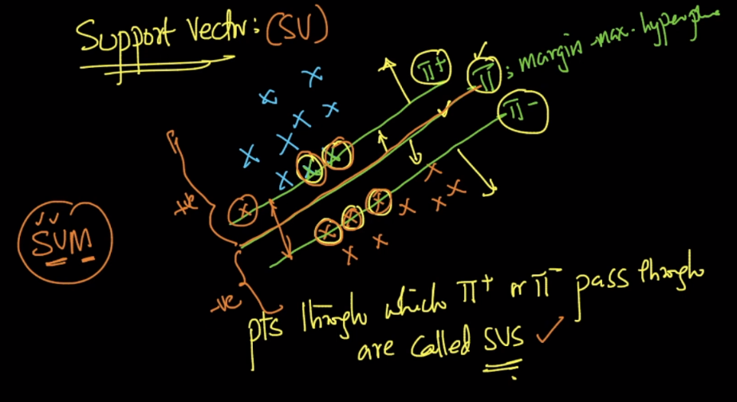

**Alternative geometric intuition of SVM:**

Let’s first understand what is convex polygon.

Given any set of data we’ll create a boundary such that all the points in that dataset are either inside or on that polygon.

Now after creating polygon, if all lines connecting any point to any point lies inside polygon such polygon is called convex polygon.

Below image shows Convex polygon and non convex polygon, see in non-convex polygon, line connecting points crosses the boundary and lie outside polygon.

Now we come to **gemotric intuition**:

So what we do is create convex hull for both classes of points.

Now find the shortest line connecting both the convex hull.

Then take the plane which perpendicular bisect the line connecting both the hull

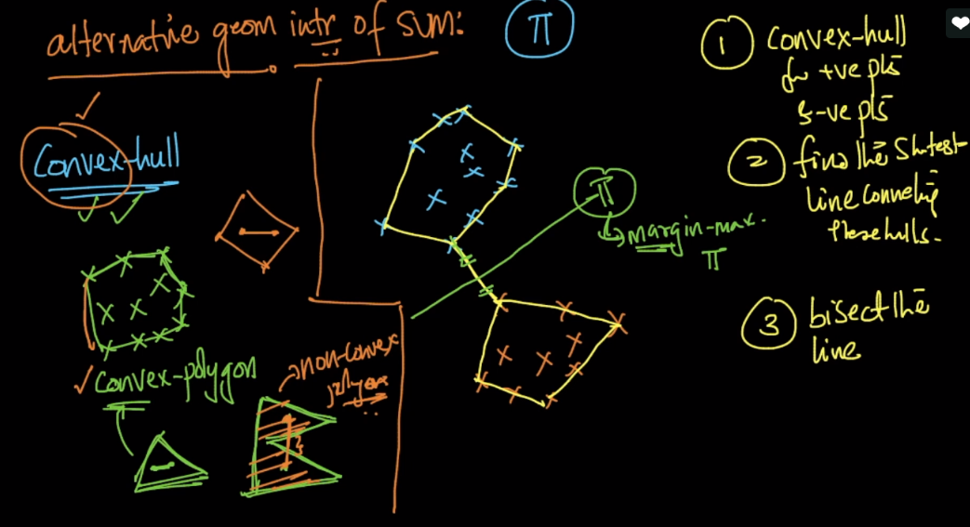

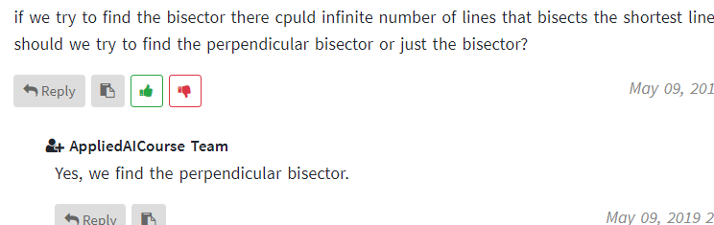

Comment About Support Vector for alternative geometric intuition.

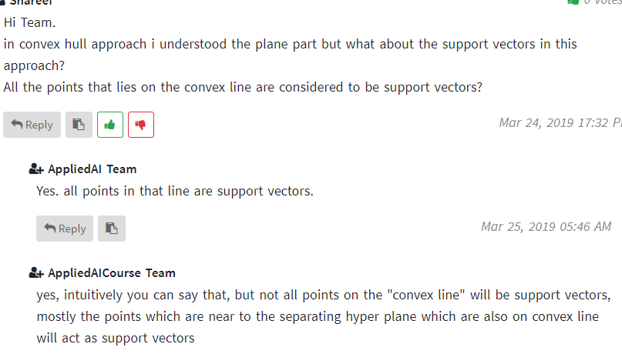

Comments:

1)

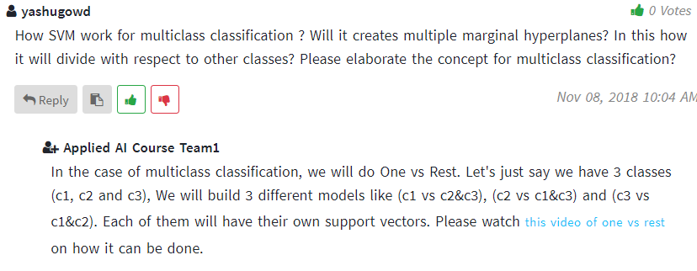

2)

